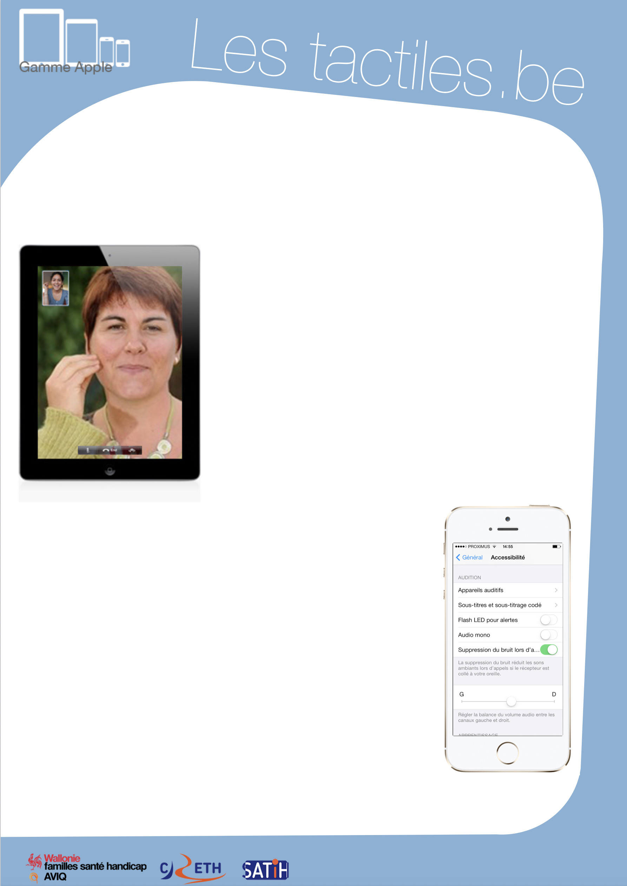

Link for Les tactiles.be

Image: A picture of Apple devices.

The accessibility tags of your tablets and smartphones

iPad, iPod, iPhone for people who are deaf and hearing impaired

Image: A picture of two people in a video call on an iPad.

Mono Audio

The iPad, iPod, and iPhone can direct auditory content from left and right audio channels in both earpieces. This allows users with a hearing impairment in one ear to listen to both audio channels in each ear simultaneously.

You can also modify the audio balance between both left and right audio channels.

Settings/General/Accessibility/Mono Audio

Image: A picture of the Accessibility menu on iPhone.

Messages with iMessage

Send unlimited messages with iMessage (without a subscription). Share videos, photos, locations and websites with friends. And thanks to group messaging, everyone can stay updated.

Settings/Message/iMessage

Image: The logos of “Wallonie familles santé handicap AVIQ”, “CRETH” and “SATIH”.

Flash LED for Notifications

Make your device’s LED diode blink to alert you of incoming calls and notifications. Or, make incoming calls display a full picture of the caller on the screen.

Settings/General/Accessibility/LED Flash for Alerts

Ambient Noise Suppression

The suppression of ambient noise reduces parasitic sounds when you are in a call in a noisy environment.

Settings/General/Accessibility/Phone Noise Cancellation

Another document will compare Facetime, Skype and Oovoo.
Three applications will allow you to make video calls online.

