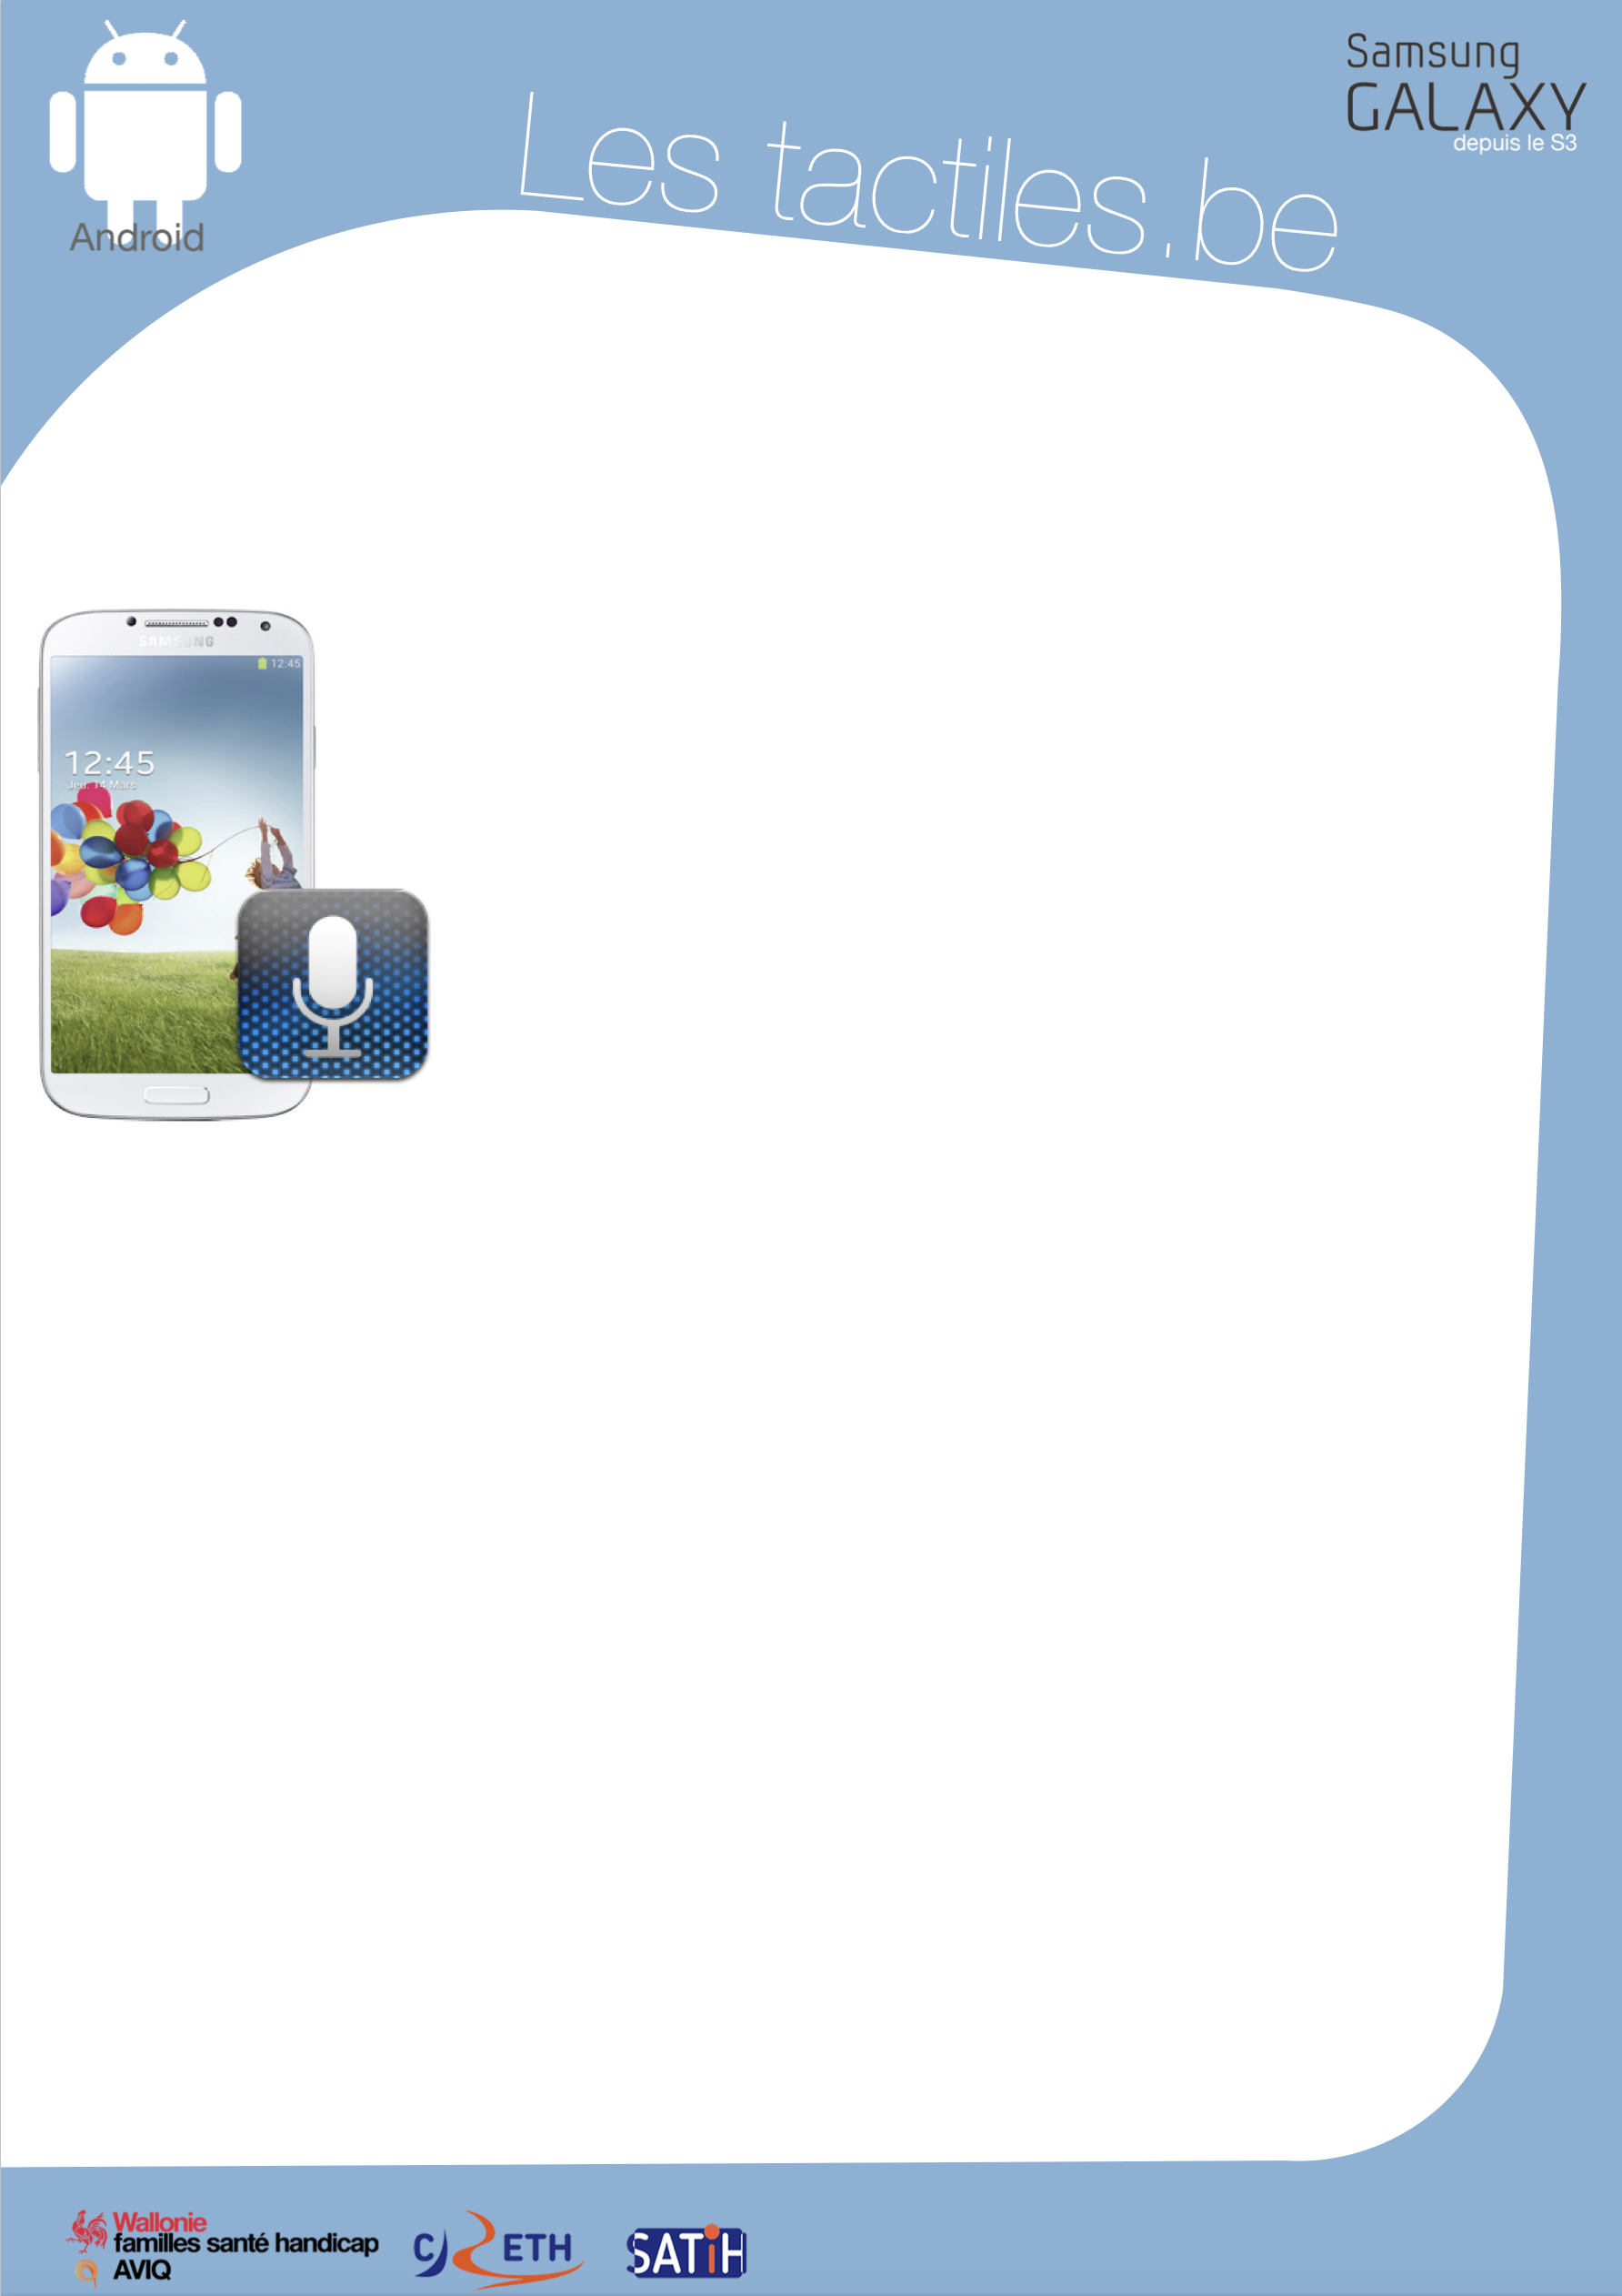

Link for Les tactiles.be

Image: A picture of Android’s mascot.

The accessibility tags of your tablets and smartphones

Learn how to use S-Voice

Image: A picture of a Samsung smartphone.

What is S-Voice?

It is a voice recognition application which answers your questions and requests.

How to access it

There are two ways to do this. The first way is to press the “Home” button on your device two times, when the “beep” sounds, you can make your request. The other way is to tap the “S-Voice” icon and access the application directly.

Example
Appointment tomorrow at 2PM at the dentist.

Here is your appointment: Dentist on 20 February 2017 at 2PM.
Would you like me to write in it your calendar?
Yes.

I will register your appointment.
Tip
Long speeches should be avoided when using “S-Voice”. You have to use keywords and be specific. “S-Voice” works with Wi-Fi or 3G, but it can also be used without it if you use applications that do not require Internet access (word processing, calendar, etc…). If “S-Voice” has difficulty answer your question or doing a task, it is important to cancel your request before asking a new question.

When you are on “S-Voice”, you will find two buttons that are on either side of the central icon (the icon with a microphone). The one on the left will allow you to activate or deactivate speech synthesis. The one on the right will allow you to access examples of sentence wording for “S-Voice”.

Image: The logos of “AWIPH”, “CRETH” and “SATIH”.

