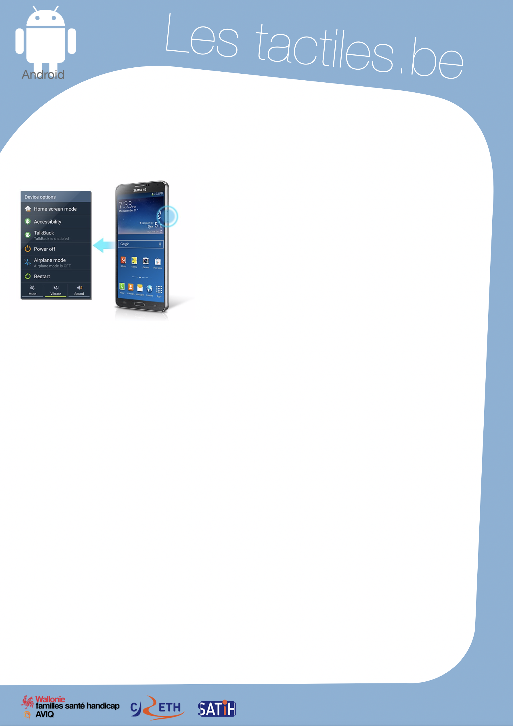

Link for Les tactiles.be

Image: A picture of Android’s mascot.

The accessibility tags of your tablets and smartphones

Quick access to Accessibility Features

Image: A picture of the accessibility menu on Android.

Description

This setting gives the possibility to activate accessibility features, such as Talkback, in just two steps:

After restarting your device,

- Press the power button on the right side of the device until you hear a sound or feel a vibration.
- Hold two fingers on the screen until you hear a sound, such as a hiss.

The accessibility features will be activated without having to go through the settings. A practical shortcut. However, you cannot deactivate the features the same way. You have to go to the settings and deactivate them one by one.

Application/Settings/Accessibility/Accessibility features shortcut

Info: To use your smartphone after activating the feature, refer to the “TalkBack” document.

Image: The logos of “AWIPH”, “CRETH” and “SATIH”.

