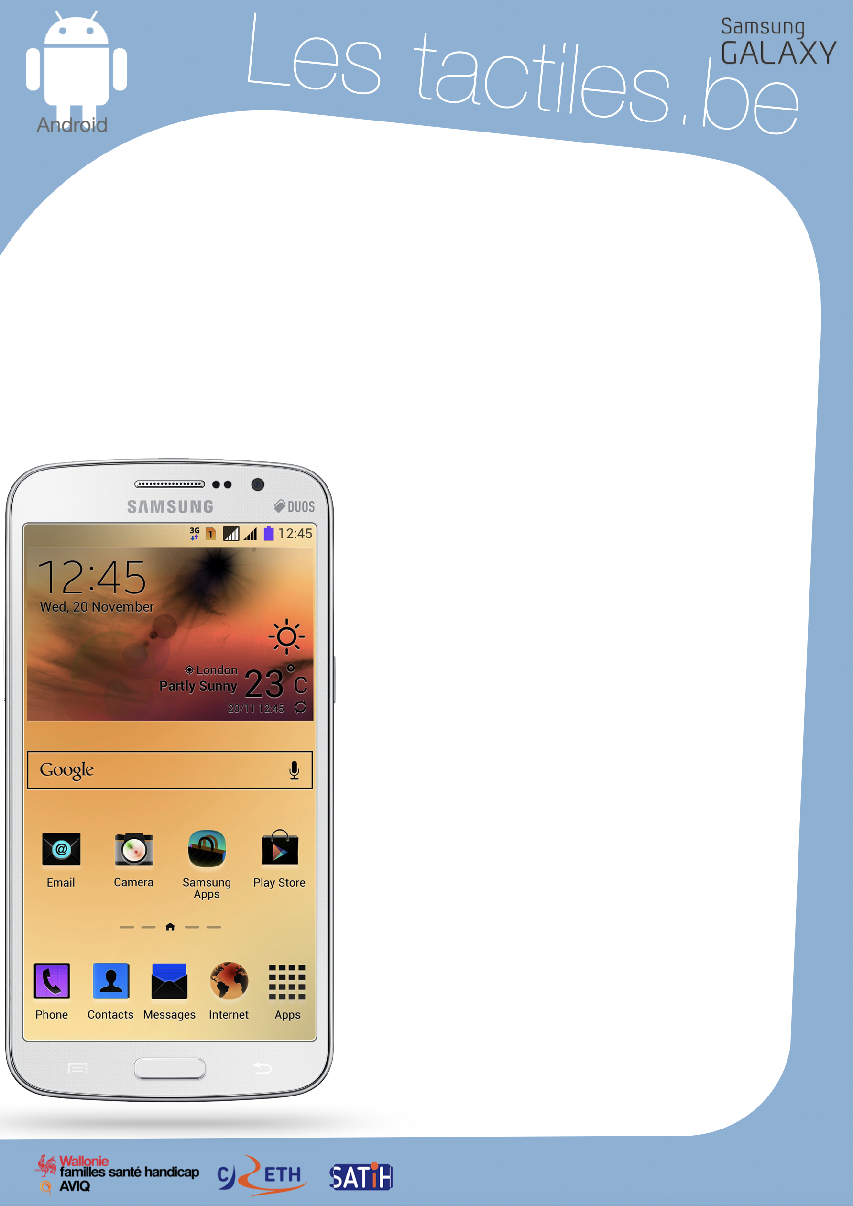

Link for Les tactiles.be

Image: A picture of Android’s mascot.

Image: A picture of the Samsung Galaxy logo.

The accessibility tags of your tablets and smartphones

Modifying the colours of the interface

The “negative colours” option

This accessibility feature allows you to switch the display to negative (inverted colours) on the screen of any application.

The “negative colours” feature can be activated through the Vision menu in Accessibility settings.

Application/Settings/Accessibility/Vision/Negative colours

The negative colours work on all screens: home screen, lock screen, as well as applications bought from the Google Play Store.

Image: A picture of an inverted screen on a Samsung smartphone.

“Grayscale” option

This accessibility feature allows you to modify the colours in shades of light gray or white on the screen of any application.

The “grayscale” feature can be activated though the Vision menu in Accessibility settings.

Application/Settings/Accessibility/Vision/Grayscale

By using the two settings “negative colours” and “grayscale,” you can get very dark shades of gray to clearer shades on the screen with any application.

In order to improve readability, it is possible to improve the intensity of the contrast with the brightness feature.

Application/Settings/Display/Brightness

On Samsung devices since 2015.
Image: The logos of “Wallonie familles santé handicap AVIQ”, “CRETH” and “SATIH”.

