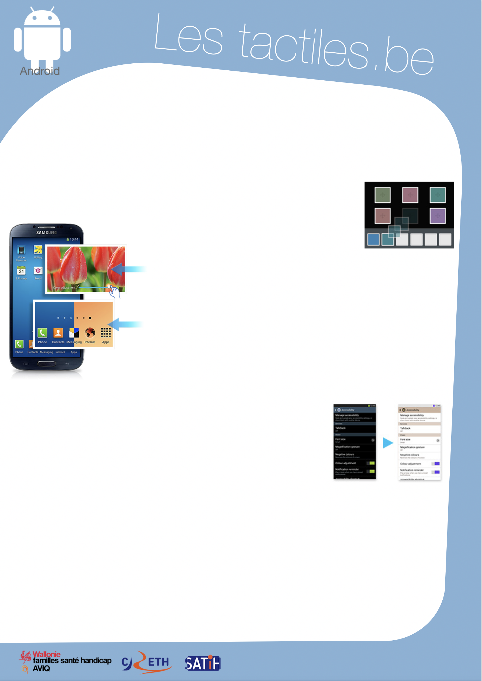

Link for Les tactiles.be

Image: A picture of Android’s mascot.

The accessibility tags of your tablets and smartphones

Adjust the colours of the screen with COLOUR ADJUSTMENT

Invert the colours of the interface with NEGATIVE COLOURS

Colour adjustment

The “colour adjustment” feature allows a fine and simple adjustment of colours on the screen. It does not alter the contrasts, but it can help with people who have colour blindness, for example.

You can find this option in the accessibility settings:
Application/Settings/My Device/Accessibility/Colour Adjustment

To adjust colours, press the small checkbox next to “Colour Adjustment” to activate the option. This will allow you to adjust the colours.

Image: A picture of squares.

Image: A picture of a Samsung smartphone.

Negative Colours

This is a feature that allows you to change the screen display to negative colour (or inverted colour).

To activate this feature, you have to go to the accessibility menu in the Settings application.

Application/Settings/Accessibility/Negative Colours

If you have difficulty reading the screen once the feature is activated, you can change the contrast with the brightness option.

Application/Settings/My Device/Display/Brightness

Info: Colour adjustment and negative colours cannot be activated at the same time.

Image: A picture of the accessibility menu for Android.

Image: The logos of “Wallonie familles santé handicap AVIQ”, “CRETH” and “SATIH”.

