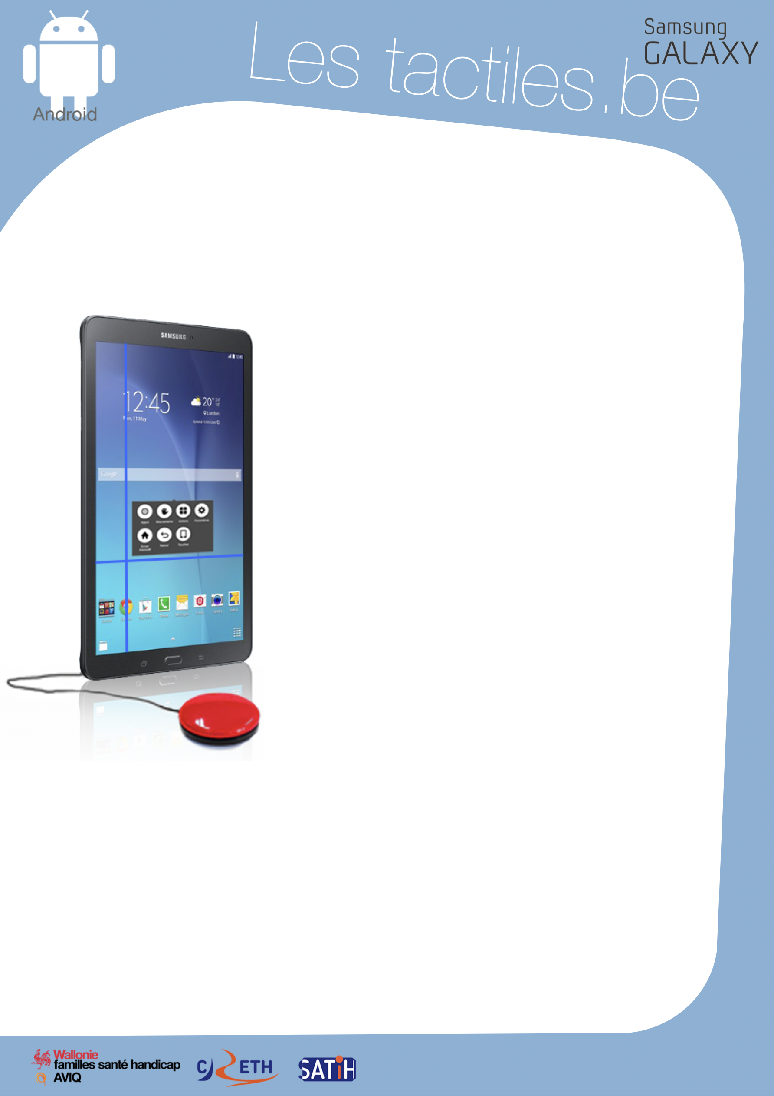

Link for Les tactiles.be

Image: A picture of Android’s mascot.

Image: A picture of the Samsung Galaxy logo.

The accessibility tags of your tablets and smartphones

Navigate by scanning thanks to the UNIVERSAL SWITCH

Image: A picture of a Samsung tablet with a universal switch.

What is the UNIVERSAL SWITCH

It is a new accessibility setting that comes with newer Samsung devices (Galaxy S6, Galaxy Tab A) and allows you to navigate by scanning:

This feature is for people with physical and motor handicaps, using one or several switches to navigate their device.

A horizontal line followed by a vertical line scans the screen of your device, waiting for a command (touching the screen or pressing a button on the connected switch). Once the action has been initiated, a menu will open to offer a selection of specific actions to facilitate navigation on the tablet or smartphone.

How to access it
Settings/Accessibility/Switch Control

Setting

The universal switch is completely configurable through the control panel where you can:
- Select the number of switches
- The duration of the scan, the number of loops and breaks
- The hold and repetition of presses on the switch
- The speed of the scan
- The sound effects and vocal information
For the family or the professionals: A shortcut will allow you to get out of the “universal switch” at any time by clicking the home button of the device three times. Conversely, this same shortcut can activate this feature.

- Etc…
Image: The logos of “Wallonie familles santé handicap AVIQ”, “CRETH” and “SATIH”.

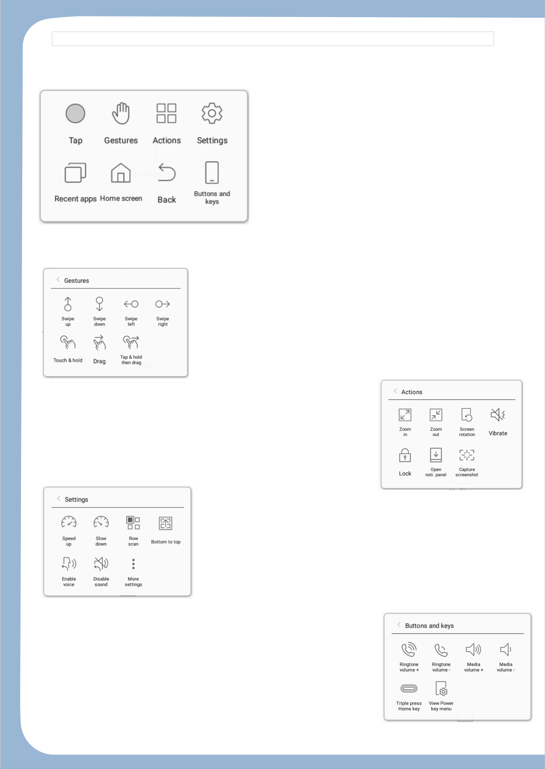
The Menus

Image: A picture of the main menu for the universal switch.
Here is the main menu of the “universal switch” where you have the ability to access other menus (see below), giving you a large possibility of choices. Once you are in this menu, a coloured rectangle will pass from one option to another while waiting for a button press form the switch or the screen, which will activate the chosen function.

Gestures menu.
This menu displays sliding input options and other types of input options.

Actions menu.
Here you will find magnifications, locks, screenshots and other features.

Settings menu.
This menu suggests shortcuts for main functions of the universal switch.

Touch menu.
Here you can control the button presses of your devices along with the functions of the telephone.

