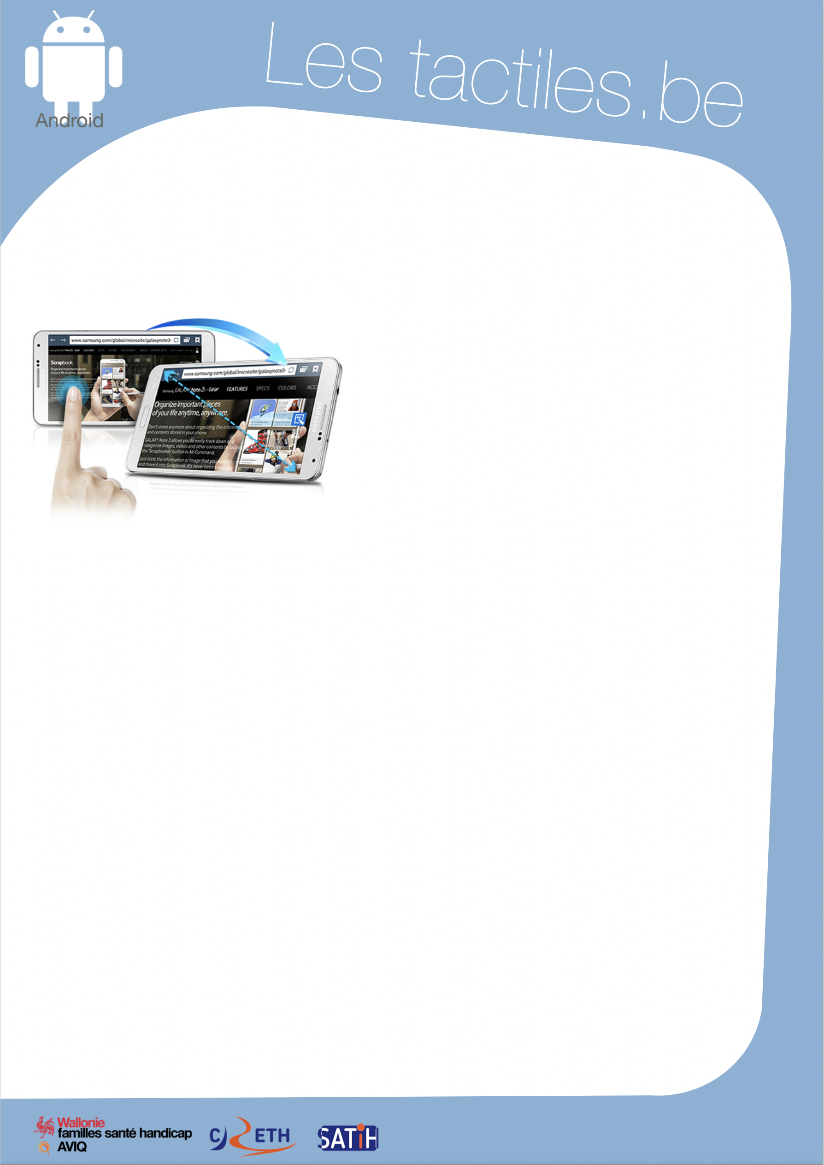

Image: A picture of Android’s mascot.

The accessibility tags of your tablets and smartphones

Zooming the interface with Magnification

Image: A picture of someone using the

Magnification application on Android.

What is Magnification

It is an option that allows you to magnify the screen of any application. It does not work on the keyboard.

How to access it

Application/Settings/My Device/Accessibility/Magnification Gestures

How to use it

Once the option is activated, you can magnify by tapping three times with one finger on the screen, then return to the normal size by doing the same thing.
When you are zoomed in, you can adjust the magnification by pinching two fingers on the screen and spread them apart or bring them together.
If you touch the screen three times with one finger but keep the finger on the screen the third time, you can navigate the application by sliding your finger on the screen. Once you lift the finger, the screen zooms out.

Magnification is available since Android version 4.2.

Image: The logos of “AWIPH”, “CRETH” and “SATIH”.

