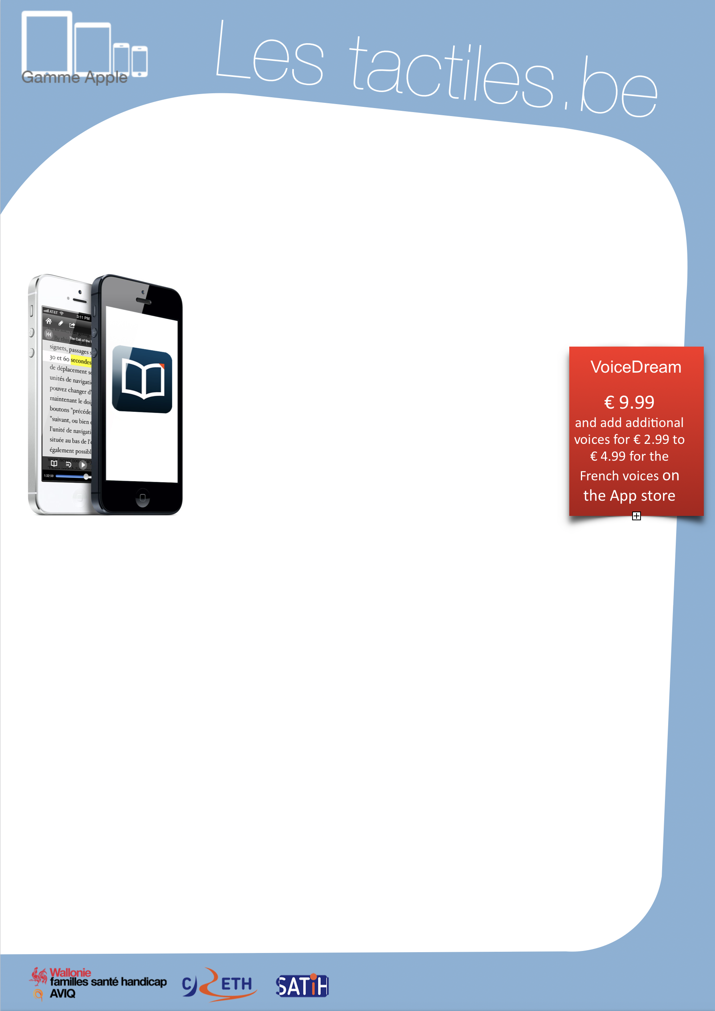

Link for Les tactiles.be

Image: A picture of Apple devices.

Image: A banner with the words “New for iOS 8.”

The accessibility tags of your tablets and smartphones

Facilitate the reading of documents, books and web articles with VOICE DREAM

Image: A picture of an iPhone with the Voice Dream Reader application

What Is It?
Voice Dream Reader allows users control the reading of all types of documents (web pages, PDF files, Daisy, DOCX, DRM-free e-books, etc.) so that it can be read by voice or displayed without formatting and pop-up ads. All you need to do is download the web article, book or instruction manual, and start the reading with the application; it is that simple.

The application does not use the voices from your device, but instead a large amount of pleasant voice choices of high quality provided by Acapela or NeoSpeech, which makes the reading enjoyable to the ear.

VoiceDream
€ 9.99
and add additional voices for € 2.99 to € 4.99 for the French voices.
Voice Dream provides a pronunciation dictionary that allows you to modify the way the voice synthesis pronounces certain words, like first names or unfamiliar towns which are often misread by voice synthesis. Afterward, each modification is documented during the reading. For a story with complicated names, this brings great listening comfort.

Also:
- Possibility of reading multiple articles one after the other.
- Possibility of programming a reading time.
(Putting the application on sleep mode to let you sleep.)
- Possibility of putting bookmarks.
- Possibility of translating text.
- Voice settings and text appearances are comprehensive and practical.
- Allows you to search for a word in a downloaded text file.

There is a free trial version of the application. However, the reading stops after a few sentences, so you have to tap on the reading icon to continue the reading each time.

Image: The logos of “Wallonie familles santé handicap AVIQ”, “CRETH” and “SATIH”.

