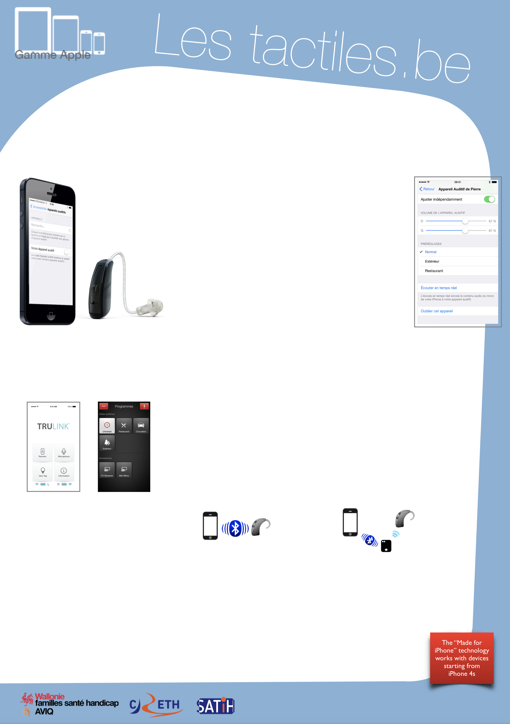

Link for Les tactiles.be

Image: A picture of Apple devices.

The accessibility tags of your tablets and smartphones

Connected Hearing Aids

Image: A picture of an iPhone and hearing aid.

Image: A picture of the hearing aid menu on iOS.

Since the arrival of iOS 7, Apple provides a control panel that allows you to interact direction with hearing aids labeled “Made for iPhone” in their accessibility settings.

Thanks to this control panel, the person can interact with the volume and on the sound reception, see the remaining battery power, etc. through your smartphone without removing their hearing aid.

Many hearing aid manufacturers have created their own applications that personalize the settings of their hearing devices. These can be used independently from Apple’s control panel menu.

Image: A picture of two menu screens from the TruLink application.

The TruLink application is made by the manufacturer StarKey, which is also comprised of the American brands: Audibel, Audigy Micro-tech, NuEar, and StarKey.

The manufacturer ReSound also has an application dedicated for their LiNX devices.

Image: A picture of a smartphone and a hearing aid connected by Bluetooth.

Image: A picture of a hearing aid connected through a phone clip, and the phone clip is connected to a smartphone by Bluetooth.

They are classified into two groups: those that connect through a third-party tool, and those that connect directly. The Bluetooth technology used here is the “Bluetooth LE” (also known as 4.0 or Smart) for Low Energy. It is supposed to be safe for your health while allowing you to save the battery power of your hearing aids. Meanwhile, those that connect through a third-party tool like a “phone clip” use 2.4 GHz wave signals.
The “Made for iPhone” technology works with devices starting from iPhone 4s.

Image: The logos of “Wallonie familles santé handicap AVIQ”, “CRETH” and “SATIH”.

